Medicine by Design
Pivotal Experiment Fund

GOAL
Medicine by Design’s vision is to harness the power of regenerative medicine to enable people around the world to live longer, healthier lives. Enabled by cutting-edge technologies such as single-cell analysis, computational modelling and synthetic biology, regenerative medicine aims to reverse disease by repairing or regenerating damaged cells, tissues and organs. It seeks to devise new approaches that will change the way disease is identified, treated and eventually cured, and block the processes that trigger disease. Increasingly, regenerative medicine uses a stem cell lens to identify critical interactions or defects that prepare the ground for disease, paving the way for new approaches to preventing disease before it starts.
The goal of Medicine by Design’s Pivotal Experiment Fund (PEF) is to build a robust, pre-clinical pipeline of regenerative medicine-based therapies, enabling technologies and ventures that have strong potential for clinical, socio-economic and/or commercial impact. A pivotal experiment is one that enables a “go/no go” decision on the merits of a product concept based on outcomes that drive a value inflection in the development plan.

PURPOSE
The PEF will bridge a critical gap within the innovation ecosystem by supporting early-stage regenerative medicine research discoveries to a point where follow-on investment from third parties is attractive. The PEF is a strategic and competitive program intended to advance translation of select Medicine by Design Cycle 2 projects.
The PEF will:
- Provide project funding of up to $250,000 for 6 to 12 months. In exceptional cases, consideration may be given to a larger investment, subject to discussions with Medicine by Design during the proposal development process.
- Support the generation of pivotal proof-of-concept and/or validation data, enabling the first steps towards demonstrating therapeutic potential and/or technological utility.
- Support projects that are defined by clear, milestone-driven (clear go/no go) decision points over 6 to 12 months.
- Encourage projects that leverage co-investment from ecosystem partners and programs (e.g. Connaught Innovation Award, UHN Innovation Acceleration Fund, CCRM, TIAP/LAB150, industry partners etc.).

Project activities can include but are not limited to:
- Generation of pre-clinical, pivotal in vivo efficacy and/or proof-of-concept data.
- Demonstration of a technology for a regenerative medicine application.
- Critical, pivotal experiments to support the early stages of target validation.
- Drug screening on a validated target.
- Demonstrating feasibility of cell manufacturing scale-up.

ELIGIBILITY
Applicants
- PEF lead PIs must be a member of a current Medicine by Design Cycle 2 project team (lead or co-PI) or a Medicine by Design new investigator.
- All investigators must have a faculty appointment at the University of Toronto.
- All funds are to be spent at the academic institution(s) except as noted under expert services.
- NOTE: Applicants may re-submit a revised proposal in round 3 if they were not successful in a previous submission.
Project stage
- Intellectual Property
  - The PEF supports projects for which intellectual property (IP) has been or is in the process of being filed at the technology transfer offices (TTO) of U of T or its affiliated hospitals.
  - In exceptional cases, Medicine by Design may consider PEF applications for technologies that have not yet been disclosed; however, applicants are expected to engage with their TTO in conjunction with the preparation of a PEF application to demonstrate a clear plan for filing IP.
- Technology Readiness Level (TRL)
  - Product concepts are expected to be at a TRL 3 (“Identification and Characterization of a Product Candidate”) as defined by the NIH TRL Scale (Appendix A).
  - Project plans are expected to advance product concepts to a TRL 4 (“Optimization and Initial Demonstration of Safety and Efficacy”) or higher).

Project Expenditures
- Eligible expenses include research expenses (salaries and benefits, equipment, materials and supplies) and expert services that are directly related to PEF project aims and deliverables.
- Funds are to be spent in accordance with the specific project approved budget and within Canada First Research Excellence Fund (CFREF) guidelines. Please see CFREF Financial Administration Guide at http://www.cfref-apogee.gc.ca/program-programme/admin_guide-guide_administration-eng.aspx.
- Expert services could include:
  - Key Opinion Leader consultations.
  - The services of a contract research organization, in cases where there is a demonstrated need for further support beyond what is feasible in an academic research lab. (e.g. independent data validation).
  - Regulatory expertise to inform pre-clinical strategy.
  - Notes about expert services:
    - Budget for expert services may be capped. Applicants are encouraged to discuss expert service needs with Medicine by Design during the proposal development process.
    - Expert services cannot be performed by companies where team members are founders and/or shareholders.
    - Expert services such as those typically provided by TTOs (e.g. patenting costs, market research, standard due diligence etc.) will not be considered as eligible expenses.
    - Requested expert services should not duplicate previous efforts by partner organizations (e.g. CCRM) but may build upon those efforts.
    - Procurement of expert services must comply with the procurement guidelines of the institution where the granted PEF funds are held.

Ineligible Expenditures
- Costs not directly associated with PEF project aims and deliverables.
- Costs related to proposal development (including staff costs);
- Capital costs (e.g. equipment over $2,500, land, buildings, vehicles, etc.).
- Travel and publication costs

APPLICATION PROCESS
Medicine by Design plans to run three PEF funding rounds, with EOI submissions in March 2021, August 2021 and February 2022. Each round will commence with an expression of interest (EOI). Successful EOIs will be invited to submit full PEF proposals. Submission deadlines are listed in the table below.
Applicants may re-submit their proposal in a later round if they are not successful in their first submission.

Review Process
PEF proposals will be reviewed by Medicine by Design’s Pivotal Experiment Fund Investment Committee. Please reference Appendix B for a list of committee members and their affiliations.
Teams that are invited to submit a full proposal will also be required to attend a meeting with the investment committee for a Q&A session.
The planned dates for each funding round are outlined in the table below. Please note that these dates may be subject to change.
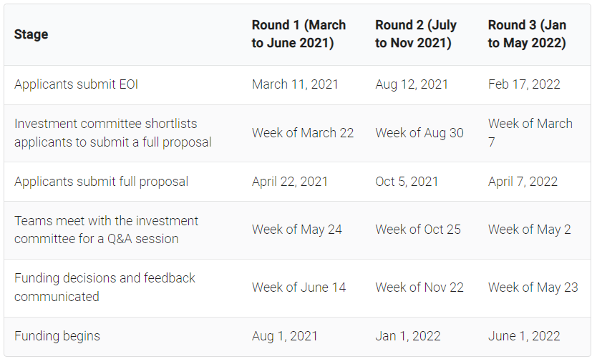

EQUITY, DIVERSITY, AND INCLUSION

The University of Toronto recognizes that diversity is essential to the creation of a vibrant intellectual community that allows our researchers to maximize their creativity and their contributions. Medicine by Design is therefore strongly committed to diversity in research and especially welcomes applications that engage racialized persons/persons of colour, women, Indigenous/Aboriginal Peoples of North America, persons with disabilities, LGBTQ+ persons, and others who may contribute to the further diversification of ideas.

All applicants (both lead and co-PIs) are required to answer a self-identification survey if they have not already submitted one as part of another Medicine by Design award application. In completing this survey, applicants may voluntarily self-identify in all applicable groups, or they may log a response indicating that they decline the survey. Self-identification data is important to the University’s ability to accurately identify barriers to inclusion and to develop strategies to eliminate these barriers. Any information directly related to you is confidential and cannot be accessed by the reviewers or the Medicine by Design team. Aggregated results as of the closing of this posting may be shared with only a small number of designated senior administrators on a need-to-know basis.

Medicine by Design
Pivotal Experiment Fund

EXPRESSION OF INTEREST

Submission Deadlines:

Round 3 EOI Due – February 17, 2022
Round 3 Full Proposal Due – April 7, 2022

Instructions
Complete the attached Microsoft Word template and convert to a PDF document for submission.
Email the completed EOI and CV document to awards.mbd@utoronto.ca by 5 pm on the submission date listed above. Notification of receipt will be sent within one business day.

Cycle 2 Project Title (if applicable):
Pivotal Experiment Fund Project title:
Lead PI name (of this project):
Co- PI name(s) (of this project):

(Maximum 2.5 pages excluding team tables)

- Resubmission changes to proposal
For resubmitted proposals, please provide an overview of how you have addressed feedback and incorporated changes from the previous PEF submission(s).
- Product Concept
Describe the product concept (technology, therapeutic, or service) that will result from this project. What is the unmet need that this product will address? How is the product concept different from the current standard of care or currently available technologies?

To the extent possible, identify an objective benchmark for success. What is the current gold standard to which your product concept will be compared?

- Overview of the Pivotal Experiment(s)
Provide an outline of the proposed pivotal experiment(s). Include an explanation of how the proposed experiment(s) will advance product development.

Describe your pivotal experiment(s) in terms of go/no-go outcomes. How will the generated data sets show a clear advantage over the gold standard or currently available technologies?

Project timelines must be less than 18 months, with deliverables completed within this timeframe.

- Intellectual property (IP) status
What is the IP?
Has the IP been published, or otherwise publicly disclosed?
Has IP been protected? If yes, provide details of the disclosure/ /patent filing. Contact your TTO for relevant details.

- Partner involvement
Briefly describe the status of engagement with institutional TTOs, local accelerators (e.g. CCRM, TIAP) and/or industry partners. Highlight engagement with commercial partners/end users, where available, as an indicator of market pull for your proposed product concept.

- Team
In the tables below, list all the team members involved in this project.
NOTE:
  - PEF Lead PIs must be a member of a current Medicine by Design Cycle 2 project team. Cycle 2 co-PIs are eligible to lead PEF proposals.
  - All investigators must have a faculty appointment at the University of Toronto.

LEAD PRINCIPAL INVESTIGATOR:
Lead PI Name: | E-mail Address:
Department & Institution:

CO-INVESTIGATORS:
Please add rows as needed.
Name | Position & Institution | Email
1.
2.

SUPPORTING DOCUMENTATION
- Attach a single PDF file with CVs for all investigators requesting funding from Medicine by Design. CVs can be in any format (e.g. CIHR Biosketch), but each CV must be less than 8 pages.

- All applicants (both lead and co-PIs) are required to answer a self-identification survey. If you have already completed this survey for another Medicine by Design awards call, you are not required to submit it again.
Please fill out the survey found at this link (https://mbd.utoronto.ca/wp-content/uploads/2020/07/MbD_Self-ID_Form_July2020.pdf) and either use the button in the form, or send by email to Andrea Gill (amk.gill@utoronto.ca), Research Equity and Diversity Strategist Research Services Office (RSO), Division of the Vice-President, Research and Innovation. Do not copy Medicine by Design staff or send this form as part of your application package.
In completing this survey, applicants may voluntarily self-identify in all applicable groups, or they may log a response indicating that they decline the survey. Self-identification data is important to the University’s ability to accurately identify barriers to inclusion and to develop strategies to eliminate these barriers. Any information directly related to you is confidential and cannot be accessed by the reviewers or the Medicine by Design team. Aggregated results as of the closing of this posting may be shared with only a small number of designated senior administrators on a need-to-know basis.

Pivotal Experiment Fund EOI – Considerations for Review
Product Concept
- Product concept is well defined.
- Team has a realistic sense of the market opportunity.
- An objective benchmark for measure success is described.
- Product concept has differentiating features that are innovative compared to existing product landscape.

Pivotal Experiment Plan Outline
- Proposed experiments are true pivotal experiments and are outlined in terms of go/no go milestones.
- Consideration has been given to data set(s) required to demonstrate advantage(s) compared to gold standard or currently available technologies.

Intellectual Property
- IP exists and has been protected.
- If IP has not been protected, a plan for protection is described.

Partner/End User Engagement
- Team has engaged with potential commercial partners or end users (e.g. clinicians) and there is potential for commercialization or clinical translation.

Appendix A: Pivotal Experiment Fund Investment Committee Members
Name | Affiliation
Committee Chair: Michael Sefton | Executive Director, Medicine by Design
Bharat Srinivasa | Co-Founder and Principal, Amplitude Ventures
Cynthia Lavoie | President and Chief Investment Officer, CCRM Enterprises Inc.  Co-Founder & Managing Director, AlloSteRx Captial
Jacques Sayegh | CEO and Managing Partner, Samuel Capital Partners
Jamie Stiff | Managing Director, Genesys Capital
Matthew Mistry | Market and Equity Analyst, CCRM Enterprises Ltd.
Parimal Nathwani | CEO, Toronto Innovation Acceleration Partners (TIAP)

